USA COMMENTS IN RED FONT
Chapter 3.2.3.
european foulbrood of honey bees (infection of honey bees with Melissococcus plutonius)
SUMMARY
Description of the disease: The causal organism of European foulbrood (EFB) of honey bees is the bacterium Melissococcus plutonius (M. plutonius). The identification of its presence by the observation of signs of disease in the field is unreliable without specialist training. The most usual and obvious sign is the death of larvae shortly before they are due to be sealed in their cells, but this may be for reasons other than EFB. Both disease signs and the presence of M. plutonius are required for diagnosis. Most infected colonies display few visible signs, which themselves often quickly abate spontaneously before the end of each active season. Infection remains enzootic within individual colonies because of mechanical contamination of the honeycombs by the durable organism. Recurrences of disease can therefore be expected in subsequent years. The disease is widely distributed worldwide and is an increasing problem in some areas.
RATIONALE: Editorial.
Detection of the agent: Examination, by high-power microscopy, of suitable preparations of larval remains for the presence of lanceolate cocci is adequate for most practical purposes, especially when it is done by experienced individuals.
Traditionally the diagnosis of EFB is done by isolating and identifying the causative organism, which can be differentiated quite readily from all other bacteria associated with bees by its fastidious cultural requirements. However, non-fastidious atypical strains have also been reported recently.
The isolated bacterium can be identified and differentiated by means of simple tube agglutination tests. A single-step conventional polymerase chain reaction (PCR) and a hemi-nested PCR are available. Real-time PCRs have also been developed. These methods permit direct analysis of larvae, adult bees and honey bee products.
Serological tests: There are no serological tests available.
Requirements for vaccines: No vaccines are available.
A. introduction
Bee larvae usually die of European foulbrood (EFB) 1–2 days before being sealed in their cells, or sometimes shortly afterwards, and always before transformation to pupae. The disease is caused by Melissococcu M. plutonius and occurs mostly during the period when colonies are growing quickly. Most sick larvae become displaced from the coiled position in the bottom of their cells before they die. Many are quickly detected and removed by nurse bees, leaving empty cells scattered randomly among the remaining brood. Some infected larvae survive, successfully pupate and emerge as adults. These surviving larvae are able to defecate and their infected-faeces contribute to the continued propagation of the disease (Bailey, 1960).
RATIONALE: Editorial.
Infected larvae that escape detection by adult bees and then die, first become flaccid and turn a light yellow colour that becomes increasingly brown, and at the same time they dissolve into a semi-liquid mass. They then become dry and form a dark brown scale that can easily be removed from the cells. Severely affected brood may have a very stale or sour odour, sometimes acidic, like vinegar, but often there is no smell.
Signs of disease usually can disappear spontaneously from infected colonies before the end of the active season, but are likely to return in subsequent years (Bailey & Ball, 1991; Forsgren et al., 2013). Geographically, the disease appears to vary in severity from being relatively benign in some areas but increasingly severe in others (Forsgren et al., 2013).
Generally, EFB has always been considered less serious than American foulbrood (AFB) because rates of recovery from EFB are higher than those from AFB, and it can often clear up with few or even without little or no intervention. However, it remains a disease of national and global concern. Indeed, more aggressive forms of the bacterium have been described in different countries (Arai et al., 2012; de Leon-Door et al., 2018; Nakamura et al., 2020). Furthermore, cases of a so-called atypical EFB (Gaggia et al., 2015; Roy & Franco, 2021) are frequently reported. Atypical EFB is reported to be responsible for more serious, harder to clear up, recurrent outbreaks.
1. Epizootiology and clinical signs
The general signs observed in a colony are irregular capping of the brood, capped and uncapped cells irregularly distributed over the brood frame (Figure 1). EFB usually affects young larvae, which die while still coiled before they are sealed. The younger larvae affected cover the bottom of the cell and are almost transparent, with visible trachea. The colour of the larvae change from pearly white to yellow, and then brown (Figure 2). Larvae die at the age of 4 to 5 days rarely in capped cells. Infected larvae assume unnatural positions in the cells, twisted around the walls. The larvae eventually decay to a point where they form dry rubbery scales that can easily be removed from the cells. Severely affected brood may have a very stale or sour odour, sometimes acidic, like vinegar, but often there is may be no smell, depending on the presence of saprophytes. A late infestation with Varroa, before colony collapse, can produce a similar brood appearance and is an important differential diagnosis.
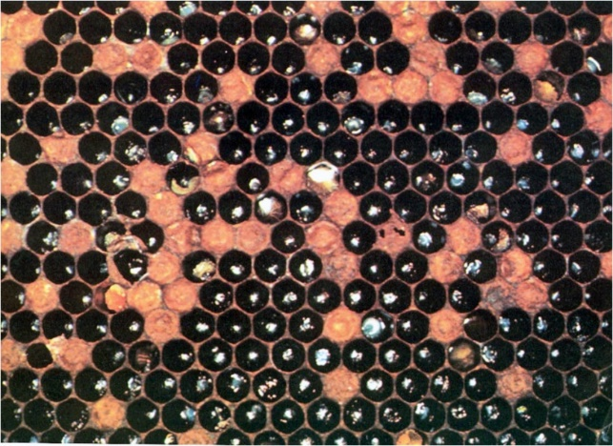

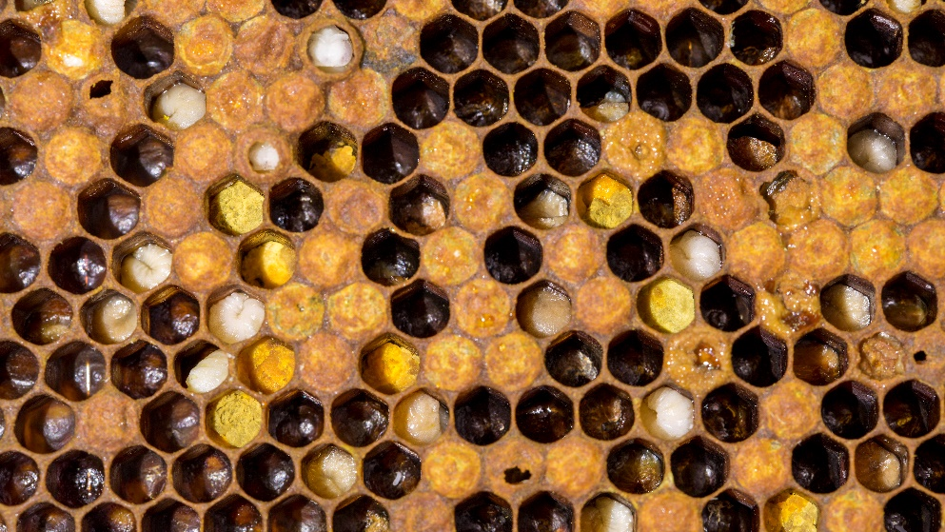
Fig. 1. Clinical European foulbrood: irregular capping of the brood.
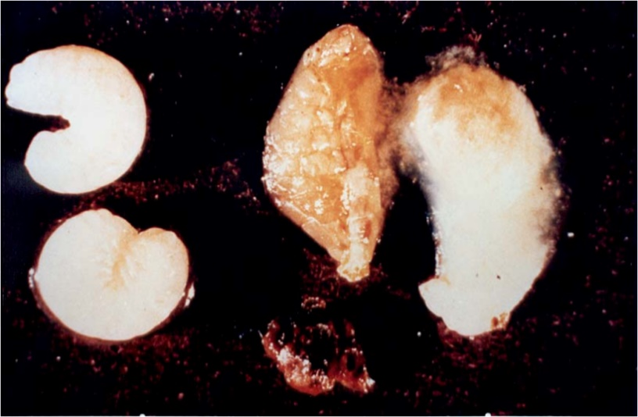
Fig. 2. The infected larvae become flaccid and turn from yellow to brown and finally
transform into a dark scale. Photo by A.M. Alippi.
Signs of EFB often appear for the first time in spring and summer, and incidence may be higher when colonies are experiencing stress following dietary stress, and usually disappear with the return of sufficient resources. However, atypical EFB cases differ from the classic descriptions of the disease: recurrent more severe signs from one year to the next that persist over time, testifying to a particular virulence. These cases could complicate field diagnosis in terms of colony outcome and visual signs (Milbrath et al., 2021; SVA report, 2020) particularly as they can be confused with AFB when the capped brood is affected and the dead larvae take on a “sticky” consistency that may resemble the viscous ‘roping’ state close to the runny nature of AFB dead larvae (Roy & Franco, 2021). Overall, this highlights the value of laboratory diagnosis and the establishment of surveillance to prevent future epidemics and newly emerging strains.
Atypical strains of M. plutonius, showing different phenotypic, biochemical and molecular characteristics, were described in Japan (Arai et al., 2012). Contrary to typical strains, atypical strains were shown to be non-fastidious, able to grow in aerobic conditions and on media without potassium salt supplementation. First considered to be restricted to Japan, their widespread distribution has been reported in Europe and the Americas (de Leon-Door et al., 2018; Wood et al., 2020). To date, M. plutonius strains have been grouped into three clonal complexes (CC3, CC12, and CC13) by multilocus sequence typing (MLST) (as of January 2022 [https://pubmlst.org/mplutonius/]). Typical strains with fastidious characteristics in culture belonged to CC3 and CC13, whereas atypical strains with non-fastidious characteristics belonged to CC12 (de Leon-Door et al., 2018; Okamoto et al., 2022; Takamatsu et al., 2014). Furthermore, whole genome sequencing (WGS) analyses suggest that the virulence factors differ between typical and atypical strains but also within the typical strains (as strains belonging to CC13 lack some putative virulence factors). The atypical strains may also have the advantage of combining faster nutrient consumption (increased metabolic capabilities with respect to usage of different nutrient sources) along with the presence of virulence factors to lead to an accelerated death of the honey bee larvae (Djukic et al., 2018). Nevertheless, further studies are needed to fully understand the virulence properties of M. plutonius strains and enhance our knowledge of the pathogenesis of typical and atypical EFB.
B. DIAGNOSTIC TECHNIQUES
Table 1. Test methods available for the diagnosis of European foulbrood and their purpose
Method | Purpose
 | Population freedom from infection | Individual hive freedom from infection prior to movement | Contribute to eradication policies | Confirmation of clinical cases | Prevalence of infection – surveillance | Immune status in individual animals or populations post-vaccination
Detection and identification of the agent^{(a)}
Bacterial isolation | +++ | +++ | ++ | +++ | +++ | –
Antigen detection | ++ | ++ | ++ | ++ | ++ | –
Microscopy | ++ | ++ | ++ | +++ | +++ | –
PCR | +++ | +++ | +++ | +++ | +++ | –
Real-time PCR | +++ | +++ | +++ | +++ | +++ | –
Key: +++ = recommended for this purpose; ++ recommended but has limitations;
+ = suitable in very limited circumstances; – = not appropriate for this purpose. PCR = polymerase chain reaction.
^{(a)}A combination of agent identification methods applied on the same clinical sample is recommended.
1. Detection and identification of the agent
Diagnosis of EFB is based on the identification of the pathogenic agent and the presence of clinical signs. An initial overview of clinical signs of the disease is provided in this chapter, followed by identification methods that require a previous culturing step, or that can be performed directly on collected samples. The techniques involved are microbiological characterisation, the polymerase chain reaction (PCR), antibody-based techniques and microscopy. The analyst should be aware of differences in sensitivity between the presented approaches and should select the most appropriate for a given situation.
1.1. Microscopy
Freshly dead larvae are best for diagnosis. Preferably before any decomposition occurs, diseased larvae can be smeared on a microscope slide or pulled apart by pinching the cuticle about the centre of the body with two pairs of forceps, which are then pulled apart. The mid gut contents are left exposed on the slide, still within the gelatinous, transparent peritrophic membrane. This is partially or almost completely filled with bacteria, which are easily seen as opaque chalk-white clumps. The contents of the mid-guts of healthy larvae, which are less easily dissected, have a golden-brown colour. Apparently healthy larvae may contain a mixture of bacteria and pollen. The mid-gut of healthy larvae that contain much light-coloured pollen may resemble those that are filled with bacteria.
Fig. 3. Bacteria associated with European foulbrood.
(a) Melissococcus plutonius: the cause of European foulbrood occurs singly, in longitudinal chains or in clusters. Morphologically resembles Enterococcus faecalis, a common secondary invader.
(b) Paenibacillus alvei: vegetative rods 2.0–7.0 × 0.8–1.2 µm with flagella; sporulating with spores lying adjacently. Both rods and spores are larger than those of Paenibacillus larvae (see American foulbrood).
(c) Achromobacter eurydice: slender, square-ended rods in vivo but can form chains of cocci in vitro
in certain media.
For a bacteriological investigation, a loopful of a dilute aqueous suspension of the midgut contents is transferred to a clean microscope slide and mixed with a loopful of 5% aqueous nigrosin. This is spread over one or two square centimetres, dried gently over a flame, and examined directly by high-power microscopy. The presence of numerous lanceolate cocci, about 0.5 × 1.0 µm in size, occurring either singly or in clusters, and arranged end to end in pairs or short chains, is almost certainly diagnostic of EFB. Some very slender square-ended rod-like bacteria are also usually present (Figure 3). Similar preparations made from aqueous suspensions of whole dead or decomposing larvae are likely to present a confusing array of bacteria in which M. plutonius will be difficult to distinguish. Alternatively, diseased larvae can be smeared on a microscope slide and submitted to the laboratory (Hornitzky & Wilson, 1989). The smears are heat fixed by flaming the slide over a burner two or three times and flooded with 0.2% carbol fuchsin for 30 seconds. Wash off the stain and allow to dry or gently blot dry with absorbent paper before microscopic examination at × 1000 (Forsgren et al., 2013; Hornitzky & Wilson, 1989). Organisms are considered M. plutonius if they are lanceolate cocci, approximately 0.5 × 1.0 µm in size, take up the stain evenly and no unstained area of the organism is detected (Figure 4). Spores are considered to be produced by the secondary invader Paenibacillus alvei if they are approximately 0.8 × 2.0 µm in size, and only the spore walls stain with 0.2% carbol fuchsin (Hornitzky & Wilson, 1989) (Figure 5). Alternatively, the Gram stain technique can be used on smears prepared from diseased brood. It allows verification of the Gram positive feature of M. plutonius, this latter appears as coccoid-shaped bacteria forming pairs or even chains (Forsgren et al., 2013). Correct sampling of brood is important because even in the same brood frame, M. plutonius is mainly found in larvae with visual disease signs (Forsgren et al., 2013).
Fig. 4. Smear prepared from disease brood stained with carbol fuchsin. Black arrows indicate a mass of coccoid/lanceolate Melissococcus plutonius organism. Green arrows indicate the presence of spores of the secondary invader Paenibacillus alvei. Photo by A. M. Alippi.
Fig. 5. Paenibacillus alvei spores in a smear prepared from disease brood stained with carbol fuchsin.
Photo by A.M. Alippi
1.2. Culture methods
During the early stages of an infection, Melissococcus plutonius (type strain NCIMB 702443) is the most abundant bacterium and is generally observed before the appearance of the varied microflora associated with this disease during the early stages of an infection (Bailey & Collins, 1982a, 1982b). Although M. plutonius can be isolated from diseased brood and honey by cultivation, bacterial culture methods seem to be very insensitive detecting less than 0.2% of the bacterial cells (Djordjevic et al., 1998).
1.2.1. Culture media
Melissococcus plutonius can be cultivated on a Basal medium (modified from Bailey, 1957) composed of (expressed in g/per litre or ml/litre) comprising:
i) 10 g yeast extract or certain peptones 10 g,
ii) 1 g L-cysteine 1 g or 1.5 0.2–2.0 g L-cysteine hydrochloride monohydrate 1.5 0.2–2.0 g,
iii) 10 g glucose or fructose 10 g,
iv) 10 g soluble starch 10 g,
v) 100 ml of 1 M KH₂PO₄ 100 at pH 6.6 and
vi) 20 g bacto agar (modified from Bailey & Collins, 1982a Bailey, 1957).
M110 agar (Forsgren et al., 2013) and KSBHI agar (Arai et al., 2012) can also be used for isolation and cultivation of M. plutonius (Forsgren et al., 2013). The medium is preferably autoclaved in 100 ml lots in screw-capped bottles at 115 116°C for 15 20 minutes and poured into Petri plates immediately before use. Optional: to prevent growth of secondary bacteria, filter-sterilised nalidixic acid (dissolved in 0.1 M NaOH) may be added to a final concentration of 3 μg per ml after autoclaving (Forsgren et al., 2013).
Note: for liquid cultures, replacing starch with saccharose will make the medium clearer more transparent. This aids when checking the turbidity or the cloudiness of the cell suspension, e.g. to see if there is any bacterial growth.
Optional: In order to prevent growth of secondary bacteria, filter-sterilised nalidixic acid (dissolved in 0.1 M NaOH may be added to a final concentration of 3 μg per ml after autoclaving) (Forsgren et al., 2013). The plates are streaked with dilute aqueous suspensions of diseased larvae, or ideally, of diseased larval mid-gut. The latter can be prepared beforehand by allowing them to dry on a slide, which may then be kept for up to 18 months at 4°C or –20°C. All culture media should be subjected to quality control and must support the growth of M. plutonius from small inocula. The A reference strain should also be cultured in parallel with the suspect samples to ensure that the tests are working correctly. The prepared plates are streaked with dilute aqueous suspensions of diseased larvae, or ideally, of diseased larval mid-gut. The latter can be prepared beforehand by allowing them to dry on a slide, which may then be kept for up to 18 months at 4°C or –20°C.
The preparation and storage of dried smears also eliminates most secondary organisms after a few weeks without affecting the viability of M. plutonius. This organism is isolated most efficiently by inoculating decimal dilutions of the aqueous suspension into agar that has been maintained molten at 45°C and which is then poured into plates. The plates must be incubated anaerobically, such as in McIntosh and Fildes jars in an atmosphere of approximately 5–10% carbon dioxide (CO₂) at 35°C for about 1 week. Small white opaque colonies of M. plutonius usually appear within 4 days. This bacterium is somewhat pleomorphic in vitro, often appearing in rod-like forms. The final pH of the medium may reach 5.5. Decreasingly fastidious strains become selected in vitro. Simplified or modified forms of the medium then support multiplication, especially of a serologically distinct M. plutonius group from Brazil (Allen & Ball, 1993) that will multiply on chemically defined media (Bailey, 1984). CO₂ remains essential. Inoculated slopes should be sealed when bacterial growth is apparent and may then be kept at 4°C for up to 6 months. Alternatively, the cultures can be suspended in a medium of 10% sucrose, 5% yeast extract and 0.1 M KH₂PO₄, pH 6.6, and then lyophilised. Isolated M. plutonius can also be stored by suspension in liquid media containing 10–30% glycerol and kept at –80°C.
A number of other bacteria are often associated with and may be confused with M. plutonius. Achromobacter eurydice inhabits the alimentary tract of adult bees and occurs commonly in the gut of healthy larvae in small numbers. It is more numerous in larvae infected with M. plutonius. The incidence of. A. eurydice in healthy bees is very low in winter and early spring, but it increases in summer. It forms thin square-ended rods, which can grow either singly or in chains. When grown in certain media, it sometimes resembles streptococci and has been confused with M. plutonius. However, its cultural characteristics closely resemble those of Corynebacterium pyogenes (Jones, 1975), and it multiplies poorly in the form of thin rods, under the conditions necessary for the cultivation of M. plutonius. The taxonomic position of A. Eurydice remains uncertain.
Enterococcus faecalis closely resembles M. plutonius morphologically and has often been confused with it, although they are both culturally and serologically distinct. Unlike M. plutonius, it does not remain viable for long when dried, or persist as mechanical contamination within bee colonies. It is probably brought into the hive by foraging adult bees, and is responsible for the sour smell sometimes encountered with EFB.
Enterococcus faecalis grows well in vitro under the conditions suitable for M. plutonius, but it may be readily differentiated by its ability to grow aerobically. It forms small transparent colonies within 24 hours and is a facultative anaerobe. It multiplies on a variety of the more common media with or without carbohydrates or CO₂. The final pH in the presence of glucose is 4.0. Enterococcus faecalis rarely exceeds the number of M. plutonius in bee larvae, and can usually be diluted out. When it is not diluted out it produces sufficient acid to prevent the in-vitro multiplication of M. plutonius.
Enterococcus faecalis does not multiply in bee larvae in the absence of M. plutonius, so its presence in large numbers can be taken as presumptive evidence of EFB.
Paenibacillus alvei is generally more common than E. faecalis in bee colonies affected with EFB, but it is not invariably associated with the disease and so cannot act as a reliable indicator of it; indeed, P. alvei has been found in colonies affected by American foulbrood as mixed bacterial spore populations on larval remains. In bee colonies, P. alvei multiplies only in the decomposing remains of larvae, and then its spores often predominate over all other bacteria, even to their apparent exclusion. Paenibacillus alvei forms very resistant spores and becomes well established in bee colonies with enzootic EFB. It causes a characteristic stale odour. Paenibacillus alvei multiplies poorly under the conditions necessary for the in-vitro growth of M. plutonius. It produces a spreading growth of transparent colonies, some of which are motile and move in arcs over the surface of the agar. Cultures have the characteristic stale odour that is associated with EFB when the bacillus is present. Spores are formed rapidly.
1.3. Immunological methods
For the identification of M. plutonius, antisera can be prepared in rabbits against washed cultures of M. plutonius either by intravenous injections (Bailey & Gibbs, 1962) or by a single intramuscular injection of 1 ml of antigen suspension mixed with an equal volume of Freund’s incomplete adjuvant.
Assays are made by agglutination tests in tubes containing suspensions of bacteria equivalent to 0.25 mg dry weight/ml. End-points are noted after tubes have been incubated for 4 hours at 37°C.
An enzyme-linked immunosorbent assay (ELISA) for confirmation of the presence of M. plutonius has been developed (Pinnock & Featherstone, 1984).
Recently, a commercially available lateral flow device for the detection of EFB using monoclonal antibodies has been developed. It provides rapid confirmatory on-site diagnosis of EFB infection in honeybee larvae in 10 minutes without the need for special equipment.
1.4. Polymerase chain reaction
Conventional PCR can be done on suspicious bacterial colonies transferred to and grown in liquid medium (Govan et al., 1998). Genomic DNA is prepared according to standard methods (Wilson, 1990). Extraction of DNA using commercial kits according to the manufacturer’s instructions is also suitable. Negative and positive controls should always be run in parallel with the test samples.
The DNA pellet is resuspended in 50 µl of 1 × TE buffer (10 mM Tris/HCl, pH 7.5; 1 mM EDTA [ethylene diamine tetra-acetic acid]). Approximately 1–3 µg of genomic DNA is amplified in a 50 µl reaction. The PCR reaction can also be done with larvae. Each larva is incubated individually in liquid medium overnight at 30°C in an anaerobic jar containing hydrogen plus 10% CO₂. Two millilitres of each sample is then centrifuged at 1000 g for 2 minutes, and the supernatant is centrifuged at 10,000 g for 5 minutes. The resultant pellet is resuspended in 100 µl of sterile H₂O and heated at 95°C for 15 minutes. One microlitre is amplified in a 50 µl PCR mixture. Besides template DNA this mixture also contains 2 mM MgCl₂, 50 pmol of forward (EFB-F) and reverse primer (EFB-R; primer sequences are given below) per µl, 25 mM (each) deoxynucleoside triphosphate and 1 U of Taq polymerase. Amplification of a specific DNA fragment occurs in a thermocycler under to the following PCR conditions: a 95°C (1 minute) step; 30 cycles of 93°C (1 minute), 55°C (30 seconds), and 72°C (1 minute); and a final cycle of 72°C (5 minutes).
When working with adult bees or honey samples commercial DNA extraction kits are recommended (Govan et al., 1998).
A hemi-nested PCR was first developed by Djordjevic et al. (1998) and thereafter improved for sensitive detection of M. plutonius in honey, pollen, whole larvae and adult bees (McKee et al., 2003). Here the first 50 µl reaction mixture contains 5–30 ng genomic DNA, 3 mM MgCl₂, 200 µM of each deoxyribonucleotide triphosphate, 100 ng of the primers MP1 and MP2, 5 µl of 10 × PCR buffer (100 mM Tris/HCl, pH 8.3; 15 mM MgCl₂; 500 mM KCl) and 1 U of Taq polymerase. Conditions of amplification consist of an initial denaturation cycle at 95°C for 2 minutes followed by 40 cycles of denaturation (95°C, 30 seconds), primer annealing (61°C, 15 seconds), primer extension (72°C, 1 minute) followed by an additional extension step of 5 minutes at 72°C. The third primer MP3 is used in conjunction with MP1 to amplify a DNA fragment from 1 µl of the primary PCR product obtained in the previous reaction. PCR conditions for the hemi-nested PCR are exactly as described above except that the MgCl₂ concentration is lowered to 1.5 mM and the annealing temperature to 56°C.
The molecular weights of the PCR products are determined by electrophoresis in a 1.0–1.5 % agarose gel and staining with ethidium bromide a suitable DNA stain. The PCR products can also be analysed using microfluidics or capillary electrophoresis devices.
A highly specific duplex PCR that can detect M. plutonius directly from diseased larvae was developed by Arai et al. (2014). It can differentiate strains that grow readily in culture from those with fastidious cultural requirements.
Real-time PCR methods have been developed and validated (Forsgren et al., 2013; Roetschi et al., 2008). They show improved sensitivity and specificity.
Ref. | Name | Sequence (5’ → 3’) | PCR-product size
Govan et al., 1998 | Primer 1  Primer 2 | GAA-GAG-GAG-TTA-AAA-GGC-GC  TTA-TCT-CTA-AGG-CGT-TCA-AAG-G | 831 832 bp
Djordjevic et al., 1998 ; McKee et al., 2003 | MP1  MP2  MP3 | CTT-TGA-ACG-CCT-TAG-AGA  ATC-ATC-TGT-CCC-ACC-TTA  TTA-ACC-TCG-CGG-TCT-TGC-GTC-TCT-C | 486 485 bp  276 bp
Roetschi et al., 2008 | MelissoF  MelissoR  Probe | CAG-CTA-GTC-GGT-TTG-GTT-CC  TTG-GCT-GTA-GAT-AGA-ATT-GAC-AAT  6’-FAM-CTT-GGT-TGG-TCG-TTG-AC-MBGNFQ | 79 bp
Budge et al., 2010 | EFBFor  EFBRev2  Probe | TGT-TGT-TAG-AGA-AGA-ATA-GGG-GAA  CGT-GGC-TTT-CTG-GTT-AGA  FAM-AGA-GTA-ACT-GTT-TTC-CTC-GTG-ACG-GT-TAMRA | 69 bp
In recent years, real-time PCR methods have been extensively developed, as culture-independent approaches to detecting both M. plutonius and P. larvae from various honey and hive samples, including larvae and adult bees. Compared with conventional PCR, these methods offer the possibility of detecting a target template with its quantification (if needed/necessary) in a robust, highly reproducible, sensitive manner and without post-PCR analysis steps, which are time-consuming and prone to contamination (reviewed by Dainat et al., 2018; Okamoto et al., 2022; Riviere et al., 2013).
As in conventional PCR, it is highly important to run appropriate controls in parallel to the test samples, positive, negative as well as inhibition controls. The use of commercial DNA extraction kits is possible (to be used according to the manufacturer’s instructions).
Regarding the choice of a PCR test for the detection of M. plutonius samples, users should consider the fitness for purpose and interpretation of acquired data before adopting such methods. Further advice can be obtained from the WOAH Reference Laboratories.
2. Serological tests
No tests for detecting antibodies in bees are available.
c. REQUIREMENTS FOR VACCINES
No vaccines are available.
Acknowledgment
Illustrations by Karl Weiss, extracted from Bienen-Pathologie, 1984. Reproduced with the kind permission of the author and Ehrenwirth-Verlag, Munich (Germany).
REFERENCES
Allen M.F. & Ball B.V. (1993). The cultural characteristics and serological relationships of isolates of Melissococcus pluton. J. Apic. Res., 32, 80–88.
Arai R., Miyoshi-Akiyama T., Okumura K., Morinaga Y., Wu M., Sugimura Y., Yoshiyama M., Okura M., Kirikae T. & Takamatsu D. (2014). Development of duplex PCR assay for detection and differentiation of typical and atypical Melissococcus plutonius strains. J. Vet. Med. Sci., 76, 491–498.
Arai R., Tominaga K., Wu M., Okura M., Ito K., Okamura N., Onishi H., Osaki M., Sugimura Y., Yoshiyama M. & Takamatsu D. (2012). Diversity of Melissococcus plutonius from honeybee larvae in Japan and experimental reproduction of European foulbrood with cultured atypical isolates. PLoS One, 7, 1–10.
Bailey L. (1960). The epizootiology of European foulbrood of the larval honey bee, Apis mellifera Linnaeus. J. Insect Pathol., 2, 67–83.
Bailey L. (1984). A strain of Melissococcus pluton cultivable on chemically defined media. FEMS Microbiol. Lett., 25, 139–141.
Bailey L. & Ball B.V. (1991). Honey Bee Pathology. Academic Press, London, UK, and New York, USA.
Bailey L. & Collins M.D. (1982a). Taxonomic studies on Streptococcus pluton. J. Appl. Bacteriol., 53, 209–213.
Bailey L. & Collins M.D. (1982b). Reclassification of Streptococcus pluton (White) in a new genus Melissococcus, as Melissococcus pluton nom. rev.; Comb. nov. J. Appl. Bacteriol., 53, 215–217.
Bailey L. & Gibbs A.J. (1962). Cultural characters of Streptococcus pluton and its differentiation from associated enterococci. J. Gen. Microbiol., 28, 385–391.
Budge G.E., Barrett B., Jones B., Pietravalle S., Marris G., Chantawannakul P., Thwaites R., Hall J.,
Cuthbertson A.G.S. & Brown M.A. (2010). The occurrence of Melissococcus plutonius in healthy colonies of Apis mellifera and the efficacy of European foulbrood control measures. J. Invertebr. Pathol., 105, 164–170. http://dx.doi.org/10.1016/j.jip.2010.06.004
Dainat B., Grossar D., Ecoffey B. & Haldemann C. (2018). Triplex real-time PCR method for the qualitative
detection of European and American foulbrood in honeybee. J. Microbiol. Methods, 146, 61–63. doi:10.1016/j.mimet.2018.01.018
De Leon-Door A.P., Romo-Chacón A., Rios-Velasco C., Zamudio-Flores P.B., Ornelas-Paz J.J. & Acosta-Muñiz & C.H. (2018). Prevalence, typing and phylogenetic analysis of Melissococcus plutonius strains from bee colonies of the state of Chihuahua, Mexico. J. Invertebr. Pathol., 159, 71–77.
Djordjevic S.P., Noone K., Smith L. & Hornitzky M.A.Z. (1998). Development of a semi-nested PCR assay for the specific detection of Melissococcus pluton. J. Apic. Res., 37, 165–174.
Djukic M., Erler S., Leimbach A., Grossar D., Charrière J.D., Gauthier L., Hartken D., Dietrich S., Nacke H., Daniel R. & Poehlein A. (2018). Comparative genomics and description of putative virulence factors of Melissococcus plutonius, the causative agent of European foulbrood disease in honey bees. Genes (Basel), 9, 1–20.
Forsgren E., Budge G.E., Charriere J.-D. & Hornitzky M.A.Z. (2013). Standard methods for European foulbrood research. J. Apic. Res., 52, 1–14. doi 10.3896/IBRA.1.52.1.12.
Gaggia F., Baffoni L., Stenico V., Alberoni D., Buglione E., Lilli A., Di Gioia D. & Porrini C. (2015). Microbial investigation on honey bee larvae showing atypical symptoms of European foulbrood. Bull. Insectol., 68, 321–327.
Govan V.A., Brozel V., Allsopp M.H. & Davison S. (1998). A PCR detection method for rapid identification of Melissococcus pluton in honeybee larvae. Appl. Environ. Microbiol., 64, 1983–1985.
Hornitzky M.A.Z & Wilson S.C. (1989). A system for the diagnosis of the major bacterial brood diseases of honeybees. J. Apic. Res., 28, 191–195.
Jones D. (1975). A numerical taxonomic study of Coryneform and related bacteria. J. Gen. Microbiol., 87, 52–96.
McKee B.A., Djordjevic S.P., Goodman R.D. & Hornitzky M.A. (2003). The detection of Melissococcus pluton in honey bees (Apis mellifera) and their products using a hemi-nested PCR. Apidologie, 34, 19–27.
Milbrath M.O., Fowler P.D., Abban S.K., Lopez D. & Evans J.D. (2021). Validation of Diagnostic Methods for European Foulbrood on Commercial Honey Bee Colonies in the United States. J. Insect Sci., 21, 1–6, https://doi.org/10.1093/jisesa/ieab075.
Nakamura K., Okumura K., Harada M., Okamoto M., Okura M. & Takamatsu D. (2020). Different impacts of pMP19 on the virulence of Melissococcus plutonius strains with different genetic backgrounds. Environ. Microbiol. 22, 2756–2770.
Okamoto M., Furuya H., Sugimoto I., Kusumoto M. & Takamatsu D. (2022). A novel multiplex PCR assay to detect and distinguish between different types of Paenibacillus larvae and Melissococcus plutonius, and a survey of foulbrood pathogen contamination in Japanese honey. J. Vet. Med. Sci., 84, 390–399. doi: 10.1292/jvms.21-0629.
Pinnock D.E. & Featherstone N.E. (1984). Detection and quantification of Melissococcus pluton infection in honeybee colonies by means of enzyme-linked immunosorbent assay. J. Apic. Res., 23, 168–170.
Roetschi A., Berthoud H., Kuhn R. & Imdorf A. (2008): Infection rate based on quantitative real-time PCR of Melissococcus plutonius, the causal agent of European foulbrood, in honeybee colonies before and after apiary sanitation. Apidologie, 39, 362–371.
Riviere M.P., Ribiere M. & Chauzat M.P. (2013). Recent molecular biology methods for foulbrood and nosemosis diagnosis. Rev. Sci. Tech., 32, 885–892. doi: 10.20506/rst.32.2.2207.
Roy C. & Franco S. (2021). Investigation of an atypical case of European foulbrood in France. Vet. Rec. Case Rep., 9:e45. https://doi.org/10.1002/vrc2.45.
SVA Report. (2020). Surveillance of infectious diseases in animals and humans in Sweden 2020, National Veterinary Institute (SVA), Uppsala, Sweden. SVA:s rapportserie, 68, 1654–7098.
Takamatsu D., Morinishi K., Arai R., Sakamoto A., Okura M. & Osaki M. (2014). Typing of Melissococcus plutonius isolated from European and Japanese honeybees suggests spread of sequence types across borders and between different Apis species. Vet. Microbiol., 171, 221–226.
Wilson K. (1990). Preparation of genomic DNA from bacteria. In: Current Protocols in Molecular Biology, Ausubel F.M., Brent R., Kingston R.E., Moore D.D., Smith J.A., Seidman J.G. & Struhl K., eds. Greene Publishing Association and Wiley Interscience, New York, USA, 241–245.
Wood S.C., Chalifour J.C., Kozii I.V., Medici De Mattos I., Klein C.D., Zabrodski M.W., Moshynskyy I., Guarna M.M., Wolf Veiga P., Epp T. & Simko E. (2020). In Vitro Effects of Pesticides on European Foulbrood in Honeybee Larvae. Insects, 11, 252. https://doi.org/10.3390/insects11040252.
*
* *
NB: There is a WOAH Reference Laboratory for European foulbrood
(infection of honey bees with Melissococcus plutonius) (please consult the WOAH Web site:
https://www.woah.org/en/what-we-offer/expertise-network/reference-laboratories/#ui-id-3).
Please contact the WOAH Reference Laboratories for any further information on
diagnostic tests and reagents for bee diseases
NB: First adopted in 1989 as European foulbrood disease. Most recent updates adopted in 2016.

https://www.woah.org/en/what-we-offer/expertise-network/reference-laboratories/#ui-id-3

