MRP USA Staffing Onboarding Buddy – Tracking New Hire Progress
Overview:
The Onboarding Buddy role in USA Staffing (USAS) can view any in progress new hire records within their assigned program area (e.g., VS D&B, PPQ S&T). This role allows an Onboarding Buddy to monitor where the new hire is at in completing the pre-employment process and can also assist managers when necessary with reaching out to a selectee to keep the process moving forward (e.g., OF-306 not completed, fingerprints not submitted).
- See Appendix A for USA Staffing Rules of Behavior
- See Appendix B for browser compatibility
- See Appendix C for instructions for clearing your browser history

Onboarding System Access: | The Onboarding Buddy will need permission to USA Staffing as an Onboarding User.  To request Onboarding Buddy access or for issues accessing the system, please email HR.System.Access@usda.gov.  Please review USA Staffing rules of behavior at the end of this document as needed.  Login to USA Staffing Onboarding  - Type www.USAStaffing.gov into your web browser.  *We recommend working in a Google Chrome web browser.  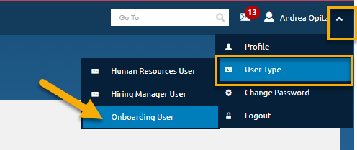  - Log in with your PIV credentials (click sign in  with smart card).  - Once logged in, select the  drop-down in the upper right corner next to your name.  - Select User Type -Onboarding User  NOTE: If the Onboarding Buddy also has a Hiring Manager User role in USA Staffing, the Onboarding Buddy will need to make sure they are working under the Onboarding User type. To check or change User Type, navigate to the user type by clicking the drop-down caret next to the user’s name in the top right corner of the system.  The New Hire can access their onboarding record by using the unique link that is listed in any USA Staffing Onboarding system notification sent to their personal email address on file.
Viewing New Hire Records | To view available new hire records, select the New Hires tab as shown below.  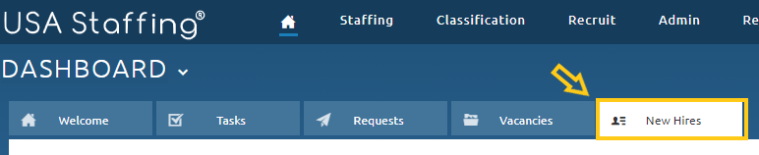  No new hire records will immediately display, because in the Onboarding Buddy role you will never be assigned as the Process Owner of a new hire record, only HR staff are assigned as the Process Owner.  You will need to select the Modify Filters button and change the Process Owner dropdown from your name to “All Owners” and select the Apply button on the bottom left.  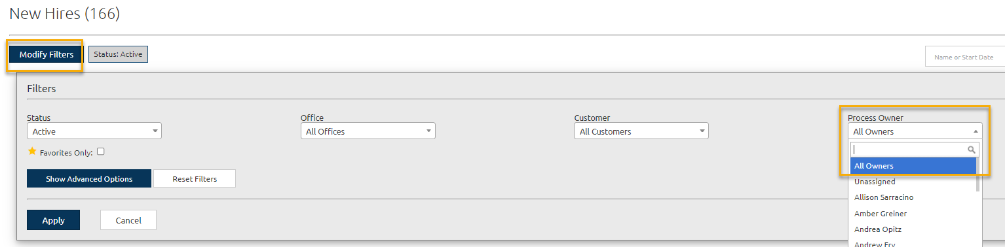  After filtering appropriately, you will see any active new hire records in progress for your program area. By clicking on the new hire’s name you will be able to view their new hire record activity and progress in the pre-employment process.  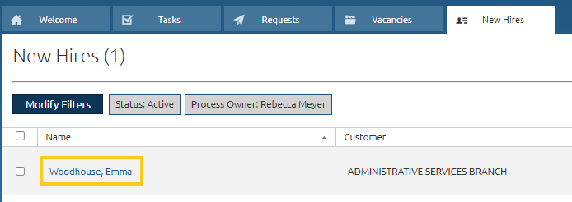
Overview Tab | Select the Overview tab to view general onboarding information and notification history for your new hire.  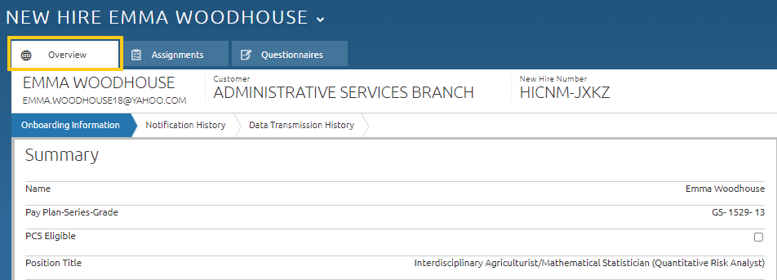  What information is available on the Overview tab?  - Onboarding Information chevron:  - General position and organizational structure information  - SF-52 Request Number being used for the selection  - Vacancy, announcement, and certificate number (if selected from a posted JOA)  - Tentative/Official Offer acceptance status (only visible after tentative/official offer letter has been sent to the new hire)  - Notification History chevron:  - Complete history of notifications sent to a new hire (e.g., tentative offer letter, Personnel Security notification)  - Notifications can be viewed by clicking either the HTML or PDF hyperlinks in the far-right column next to each notification.
Assignments Tab | Select the Assignments tab to view specific information about the remaining tasks, documents, and/or forms that your new hire has assigned to them. USAS will default to showing tasks assigned to Human Resources, so you will need to select that dropdown and update it to New Hire to view the outstanding tasks they may need to complete.  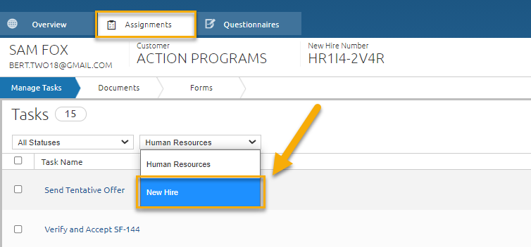  What information is available on the Assignments tab?  - Manage Tasks chevron (Human Resources selected in the drop-down):  - Human Resources assigned tasks – will show if HR is still waiting on responses/documentation such as:  - Receive Tentative Offer Response  - Receive SF-75 information and release date from losing agency (transfers)  - Manage Tasks chevron (New Hire selected in the drop-down):  - New Hire assigned tasks – will show all assigned tasks, status (Pending, Active, or Complete), along with due dates and completion dates if the task has been completed.  - If a new hire has not yet completed required tasks such as Sign and Submit OF-306 or Make Fingerprint Appointment, you may want to reach out to them and encourage them to get the task completed as soon as possible.  - Documents chevron: Area to view a variety of documentation such as the new hire’s resume or their completed USDA Information Security Awareness Training certificate.  - Forms chevron: Area to view specific forms or required questionnaire responses that are still pending new hire action.  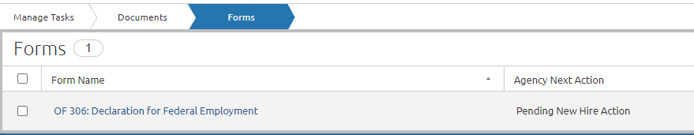
Questionnaires Tab | The Questionnaires tab includes a Manage Questionnaires chevron, with several questionnaires listed. The various questionnaires and sections within each are completed by Human Resources, the new hire, and the Onboarding Buddy at different points throughout the process. New hires are asked to complete specific portions of the questionnaire through assigned tasks and instructions provided to them by HR.  The Onboarding Buddy also needs to access the Questionnaires tab to complete required questionnaire items as part of their review and completion of the I-9 and SF-61 forms for their new hire’s day one onboarding process.  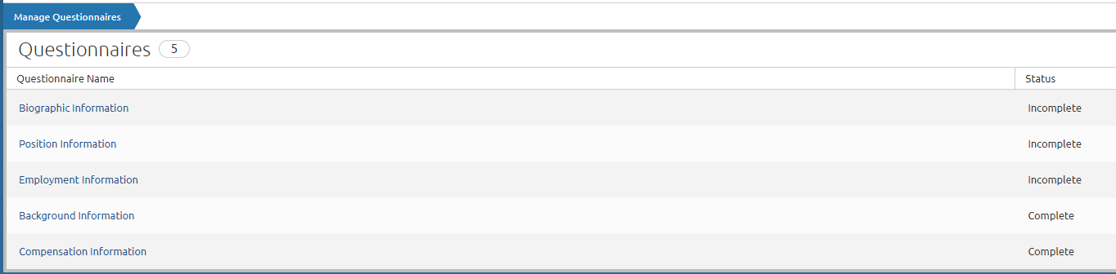
FAQs | Please review the Frequently Asked Questions below to see if your question is answered.  If you have a suggestion for a question to be added here, please email Andrea.Opitz@USDA.gov.
Has the new hire completed their Fingerprints and/or eQIP? | Navigate to the Assignments tab, Manage Tasks chevron. Change the drop-down option from Human Resources to New Hire.  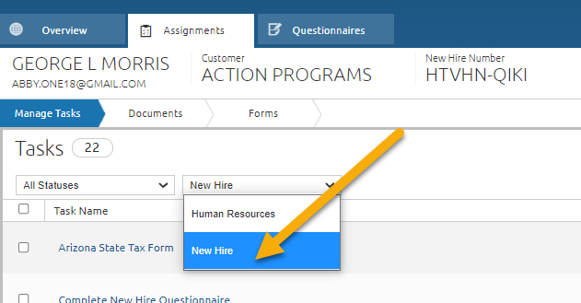  Locate the tasks titled Make Fingerprint Appointment and Release Employment Investigation Questionnaire in E-QIP System to review the task Status, Due Date and Completed Date columns.  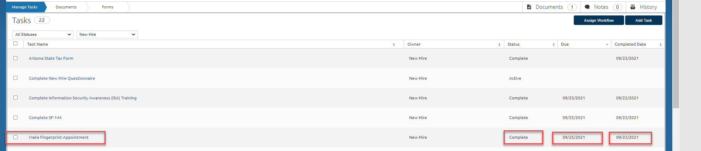  If you have questions about the Fingerprint and eQIP process, please review the Fingerprint eQIP Fact Sheet.
What happens if the new hire misses the due date? | The due dates listed for the New Hire in their Onboarding record are established to help the new hire keep on track through the Onboarding process. Most of the task due dates are arbitrary. The Benefit Task due dates are firm deadlines and Human Resources is not able to accept Benefit forms submitted past the 60-day date from their effective date (the due date listed in their onboarding record). Please help the New Hire stay on track when needed to reduce Onboarding delays.
Where can I see if the new hire accepted the tentative or official offer? | Navigate to the Overview tab, Onboarding Information chevron, under and the Tentative and /or Official Offer response will be displayed under the New Hire Summary section. 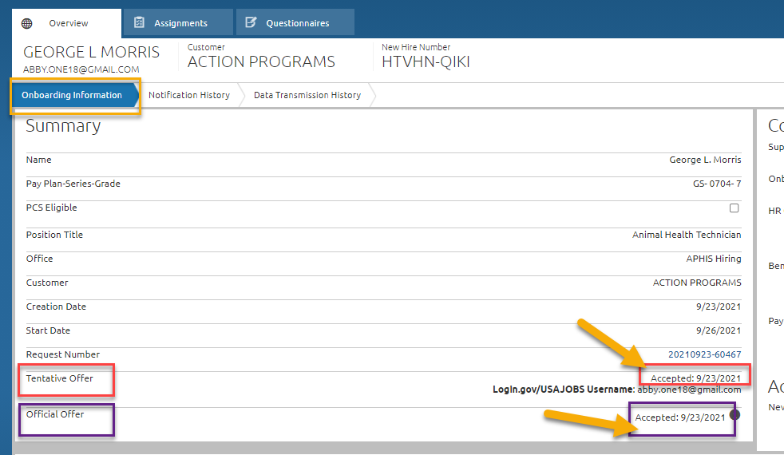
Where can I view the tentative or official offer letter(s) sent to the New Hire? | Navigate to the Overview tab, Notification History chevron to view the list of notifications that were sent to the New Hire. If the Tentative or Official offer was sent, you will see it listed here. To view the letter, click on the View Content column. We recommend clicking on the HTML option for viewing and the PDF option for downloading.  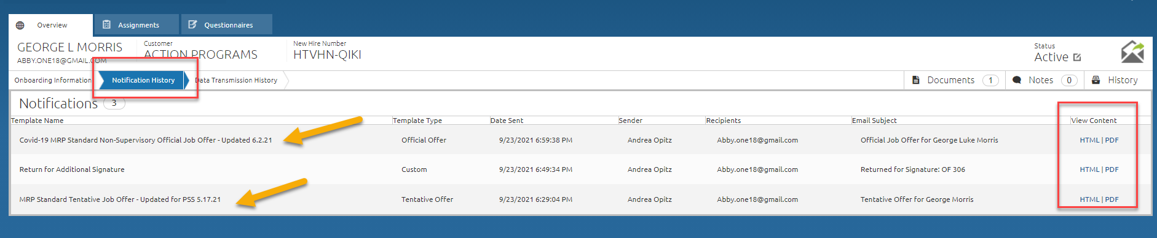
Where can I see what was told to the New Hire to complete security requirements? | Navigate to the Overview tab, Notification History chevron to view the notification titled MRP Personnel Security Notification to see what told to the New Hire as it relates to pre-employment security requirements. To view the notice, click on the View Content column. We recommend clicking on the HTML option for viewing and the PDF option for downloading.
Where can I find the HR contact names associated with the New Hire? | Navigate to the Overview tab, Onboarding Information chevron and review the Contact Information section.  - HR Contact = HR Staffing Contact(s)  - Benefit Contact = HR Benefit Assistant Contact  - Payroll Contact = HR Personnel Processing Contact  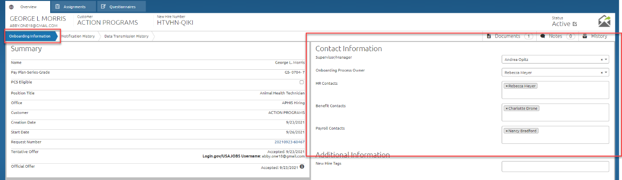
Where can I find the New Hire’s Informational Security Awareness (ISA) Training Certificate? | Navigate to the Assignments tab, Manage Tasks chevron. Change the drop-down option from Human Resources to New Hire.  Locate the tasks titled Complete Informational Security Awareness (ISA) Training or Upload Current FY Information Security Awareness (ISA) Training Certificate. Click on the task name to view the document uploaded and date completed.  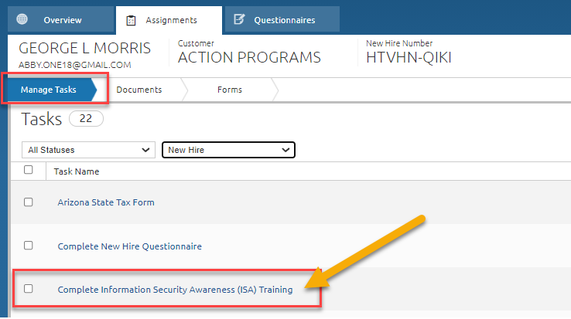
Additional Resources | Onboarding a new hire is more than just getting them to complete pre-employment paperwork and sign documents on their first day. Onboarding acclimates employees to their role, identifies USDA, Agency and Program philosophies, and what we have to offer. It also engages employees, creating workers that are committed to our success AND helps us retain them because now they feel like a member of our team!  There are onboarding resources on the New Employee Orientation site – https://www.aphis.usda.gov/aphis/ourfocus/business-services/new-employee-onboarding  - Employee Guide  - Supervisor Guide & Checklists  - Links to Benefits information – remind New Hires that all benefit’s decisions are personal ones, and they need to do their research to determine what’s best for them. The Benefits Team is available to help with forms  - Videos from President Biden and USDA Secretary Vilsack Information about eAuthentication and Linc Pass – new hires should see email invitations for these in the first pay period  - If you have questions about the Fingerprint and eQIP process, please review the Fingerprint eQIP Fact Sheet.

APPENDIX
Appendix A: USA Staffing Rules of Behavior
RULES OF BEHAVIOR
In accordance with the Office of Management and Budget (OMB) Memorandum M-06-16, Protection of Sensitive Agency Information, and to protect the confidentiality, integrity and availability of the U.S. Office of Personnel Management's (OPM's) USA Staffing system, rules of behavior on the safe handling of data must be followed when accessing Personally Identifiable Information (PII) in USA Staffing. The loss of PII can result in substantial harm, embarrassment, and inconvenience to individuals and may lead to identity theft or other fraudulent use of the information.
- I acknowledge that I have access to download Controlled Unclassified Information (CUI) in the USA Staffing system.
- I acknowledge my responsibility to ensure the confidentiality, integrity, and availability of USA Staffing information in a manner consistent with its sensitivity.
- By being granted access to Controlled Unclassified Information (CUI), I am obligated to protect this information from unauthorized disclosure.
- I agree that my obligation to safeguard the confidentiality of Controlled Unclassified Information (CUI) shall be in effect until a transfer of duties no longer requires access to this data or until termination of my employment.
- I will obtain, use or disclose such data only in connection with the performance of my official duties solely for authorized purposes. I will not disclose any data to other agencies or persons not expressly authorized to receive or have access to it. I will make any such authorized disclosures in accordance with established regulations and procedures.
- I will encrypt any PII data downloaded from USA Staffing on any portable storage device, including laptops, PDAs, iPods, thumb drives, external hard drives, etc.
- I will erase PII data downloaded from USA Staffing within 90 days unless its official use is still required.
- I will immediately report any security breach, password compromises, anomalies in system performance, or suspicious activities. I will ensure that security breaches are reported to a Federal incident response center, US-CERT, located within the Department of Homeland Security.
- I will protect my passwords and authentication tokens from disclosure and loss at all times. I will employ passwords in accordance with USA Staffing's password policy.
- I will change my default passwords immediately when assigned. I will never reveal my passwords to unauthorized individuals. I will not construct my password from obvious personal data, (i.e. social security number, telephone numbers, relative's names, pet's name, etc.).
- I will not allow others to use my User ID and I will not access other users' accounts. I will not attempt to access accounts or data that are not expressly authorized to me. I understand that I am accountable for all actions taken under my User ID.
- I understand that any changes in my employment status or changes in my job responsibilities may require my access to be modified or terminated.
- I will ensure that any work performed remotely or off-site will be provided the same level of protection as provided at the office.
- I will ensure proper protection and disposition of printed documents containing PII obtained through the USA Staffing system.
- I understand that all conditions and obligations imposed upon me by these rules apply during the time I am granted access to the USA Staffing system. I understand I am being granted permission to access OPM's USA Staffing system and data as specified above, and that my use of this access may be monitored for compliance.
- I understand that any system user who does not comply with these rules is subject to penalties including suspension or cancellation of system privileges and possible criminal prosecution. OPM will enforce the use of penalties against any user who willfully violates Federal system security.
These restrictions are consistent with and do not supersede, conflict with or otherwise alter the employee obligations, rights or liabilities created by Executive Order 12356; Section 7211 of Title 5, United States Code (governing disclosures to Congress); Section 2302(b)(8) of Title 5, United States Code, as amended by the Whistleblower Protection Act (governing disclosures of illegality, waste, fraud, abuse or public health or safety threats); the Intelligence Protection Act of 1982 (50 U.S.C. 421 et seq.) (governing disclosures that could expose confidential Government agents), and the statutes which protect against disclosure that may compromise the national security, including Sections 641, 793, 794, 798 and 952 of Title 18, United States Code, and Section 4(b) of the Subversive Activities Act of 1950 (50 U.S.C. Section 783(b)). This agreement shall not nullify or affect in any manner any other secrecy or nondisclosure Agreement which I have executed or may execute with the United States Government.
Appendix B: Browser Compatibility
USA Staffing requires HTML5 compatible browsers including current versions of:
- Chrome
- Edge
- Firefox
The Online Application and Onboarding interfaces support current versions of: Chrome, Firefox, Edge, and Safari.
Appendix C: Clearing your cache or temporary internet files
Edge:
Press Control (Ctrl), Shift, Delete (Del) on your keyboard.
- Select All time from the Time range drop-down list.
- Check Browsing history.
- Check Download history.
- Check Cookies and other site data.
- Check Cached images and files.
- Click Clear now.
Firefox:
- Click Open Menu (three horizontal lines on the right side of the toolbar).
- Click Options.
- Click Privacy & Security.
- Under Privacy & Security, click Clear Data.
- Ensure Cookies and Site Data, and Cached Web Content, are checked.
- Click the Clear.
Chrome:
- Click the Chrome menu on the browser toolbar (three vertical dots on the right side of the toolbar).
- Click More Tools.
- Click Clear browsing data.
- In the dialog that appears, select the check-boxes for the types of information that you want to remove. Make sure Browsing history, Download history, Cookies and other site and plugin data, and Cached images and files boxes are checked.
- Use the drop-down list at the top to select the amount of data that you want to delete. Select beginning of time to delete everything.
- Click Clear Browsing Data.
Safari:
- Click History on the top menu bar.
- Click Clear History button.
- Choose All History from the drop-down.
- Click Clear History.
If the browser you are using is not identified on this page, please search for "Clearing my cache" on your browser help page or search the internet to find browser-specific instructions.

