1. Newsletter Article/Blog Post

Please Don’t Move the Tamarisk Leaf Beetle

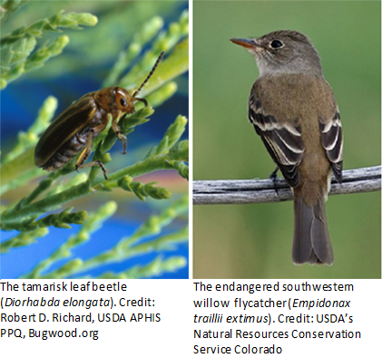
Have you heard of the endangered southwest willow flycatcher? It’s a bird that nests and feeds in dense forests of willow and non-native saltcedar (tamarisk trees) along southwestern rivers. Many organizations are working to promote its conservation, including USDA’s Animal and Plant Health Inspection Service (APHIS).

APHIS is urging landowners and land managers not to move tamarisk leaf beetles onto their properties to control saltcedar. Releasing this beetle may harm habitat critical to the flycatcher and other native wildlife. In addition, people who move the beetle interstate without a permit from APHIS may violate the Plant Protection Act—and potentially face financial penalties.

Fortunately, there are ways to control saltcedar without using tamarisk leaf beetles, and USDA has resources to help. If you are a landowner or lease holder, APHIS encourages you to work with the USDA Natural Resources Conservation Service’s Working Lands for Wildlife (WLFW) partnership. This program may be able to help you control saltcedar while conserving vital habitat for the flycatcher.

If you have planted or use saltcedar for landscaping purposes and wish to protect those trees from the beetle, discuss potential pest management options with your local Extension agent. To find an Extension office in your State, visit USDA’s Land-Grant University Website Directory and click on your State on the map. In addition, if you have concerns about wildfire risk that dead trees on your property may pose, you may wish to contact your local wildfire response organization for assistance and information.

Remember: You have the power to protect America’s landscapes and help conserve this endangered species! Take action, but please don’t move the tamarisk leaf beetle.

2. Facebook Posts

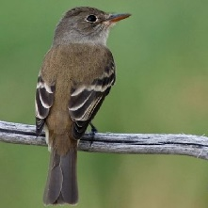
If you own or manage land in the Southwest near a river, you may be trying to control saltcedar (tamarisk trees). USDA has valuable information and resources to help you control saltcedar while protecting an endangered bird’s critical habitat. www.aphis.usda.gov/planthealth/tlb

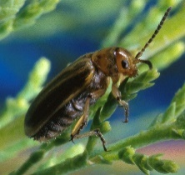
Don’t move the tamarisk leaf beetle onto your property to control saltcedar (tamarisk trees)! Doing so may harm critical habitat of the endangered southwestern willow flycatcher. Fortunately, USDA has alternatives. Learn more here: www.aphis.usda.gov/planthealth/tlb

3. Tweets

The endangered southwestern willow flycatcher can nest in saltcedar (tamarisk trees). @USDA_APHIS can help you control saltcedar on your property while protecting this bird’s habitat: www.aphis.usda.gov/planthealth/tlb

Southwest land owners and managers: Don’t move this beetle to control saltcedar (tamarisk trees)! It can harm the critical habitat of an endangered bird. @USDA_APHIS has alternatives: www.aphis.usda.gov/planthealth/tlb

